Implementation of Multilayer Neural Network using Keras on MNIST dataset

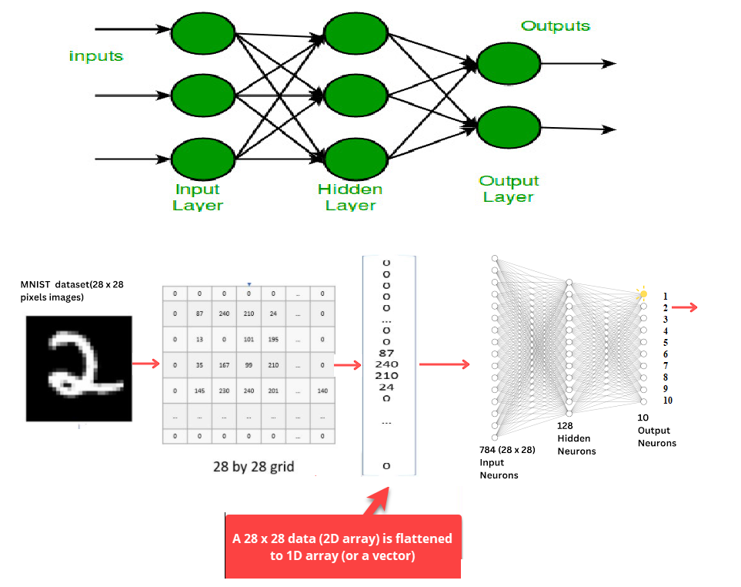

1. Data Loading and Exploration
(X_train, y_train), (X_test, y_test) = keras.datasets.mnist.load_data()
- Loads the MNIST dataset: 60,000 training and 10,000 test grayscale images (each 28×28 pixels), plus their labels
X_test.shape # e.g. (10000, 28, 28)
y_train # labels array length 60000
plt.imshow(X_train[2])
- Visualizes a sample training image (hand-written digit)

2. Normalization
python
CopyEdit
X_train = X_train / 255
X_test = X_test / 255
- Scales pixel values from 0–255 to 0–1 to help training stability and convergence

3. Model Definition
model = Sequential()
model.add(Flatten(input_shape=(28, 28)))
model.add(Dense(128, activation='relu'))
model.add(Dense(32, activation='relu'))
model.add(Dense(10, activation='softmax'))
- Flatten layer transforms each 28×28 image into a 784-length vector so that Dense layers can process it
- Dense(128): a fully connected hidden layer with 128 neurons and ReLU activation (learns patterns).
- Dense(32): second hidden layer, smaller to refine features.
- Dense(10): output layer with softmax activation producing probabilities across the 10 digit classes
model.summary()
- Lists number of parameters per layer, shapes, etc.

4. Compile & Train
model.compile(
loss='sparse_categorical_crossentropy',
optimizer='Adam',
metrics=['accuracy']
)
history = model.fit(
X_train, y_train,
epochs=25,
validation_split=0.2
)
- Loss function: sparse categorical crossentropy works with integer labels (0–9).
- Optimizer: Adam, adjusts learning rates adaptively.
- Accuracy: tracked during training.
- Validation split (20%): holds out data to monitor overfitting and generalization.

5. Evaluate and Visualize Results
y_prob = model.predict(X_test)
y_pred = y_prob.argmax(axis=1)
accuracy_score(y_test, y_pred)
- Predicts probabilities (y_prob) for each test image; selects highest probability to assign class (y_pred).
- Computes accuracy against true y_test.
plt.plot(history.history['loss'])
plt.plot(history.history['val_loss'])
plt.plot(history.history['accuracy'])
plt.plot(history.history['val_accuracy'])
- Plots curves for training loss vs. validation loss, and training vs. validation accuracy across epochs to analyze learning behavior.

6. Making Predictions on Individual Samples
plt.imshow(X_test[1])
model.predict(X_test[1].reshape(1,28,28)).argmax(axis=1)
- Visualizes one test image.
- Predicts its label by reshaping to include batch dimension (1, 28, 28), then picks the class with highest predicted probability.

